Project 6
Comparison between Solar Power Tower Direct Steam and Solar Power Tower Molten Salt

Introduction
The use of fossil fuels such as coal, peat, oil and natural gas used in electricity and heat production causes huge detriment to the environment in terms of greenhouse emissions resulting in global warming [1]. In addition, such fuels will be depleted hence an alternative source of energy that is renewable and sustainable should be considered. One of the most abundant sources of energy is solar energy of which the atmosphere receives from the sun at 1367 W/m². Solar energy is one of the cleanest and most sustainable compared to other renewable energy sources. There are different technologies (i.e. photovoltaic, solar dish/Stirling, solar power tower) to convert solar energy into electricity and power and the primary challenge is how to get this energy in efficient way. One of the most efficient techniques to use solar energy in steam production to produce electricity is the solar tower. Solar power tower (SPT) is based on heliostat which reflects the solar heat in a focus point (receiver point). Solar tower is the most favoured technology that is used in electricity generation and heat production.
The solar tower systems (STSs) have capability to meet high demand for energy needs. Solar tower infrastructures are known as one of the most costly and at the same time, most suitable energy production systems in the range of 30 –400 MW [2], [3]. In this energy production system, a heliostat field concentrates solar beams to a receiver located at the tower for heating the working fluid. This system can be used in Rankine and Brayton cycles for direct steam generation and for preheating the air before it enters the combustion chamber, respectively [4]–[6].
There are various concentrating solar technologies such as solar power tower, solar linear Fresnel and solar parabolic trough system. Between them solar power tower is extraordinary especially for large scale solar power plants. A simple idea has been applied to produce electricity or heat by SPT system, which is reflecting solar radiation on a receiver. Here, for electricity generation, we design the system by incorporating a Rankine cycle (or Brayton cycle) and receiver on top of the tower plays the role of boiler for that. Heat transfer fluid absorbs heat directly or by contact with the receiver surface and turns a steam turbine. In some industrial applications, the solar tower system is used to facilitate a chemical process like electrolysis to split water into hydrogen and oxygen (then the hydrogen generated in the process is used for different purposes such as ammonia and methanol production). Figure 1 demonstrates a solar power tower system incorporated with a double flash Rankine cycle. The power tower system composes of heliostat field, receiver (including reheater, boiler and superheater) and tower. Figure 2 shows a schematic diagram of the solar power tower molten salt (SPTMS) system. In contrast to the other prominent alternative renewable energy technologies such as wind and photovoltaic, which can generate electrical power when the wind and solar resources are available, the thermal energy produced by the solar tower system can be stored for later use.
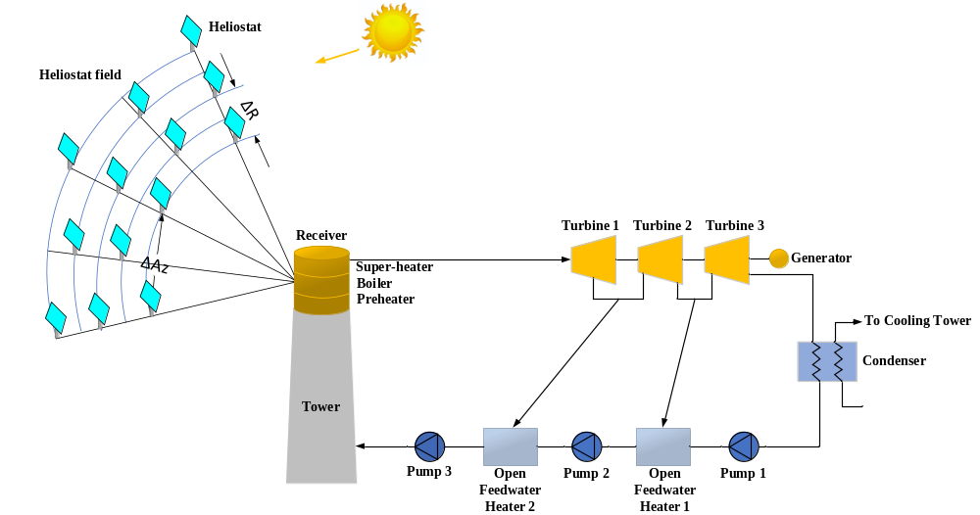
Figure 1 Solar power tower direct steam (SPTDS) system.
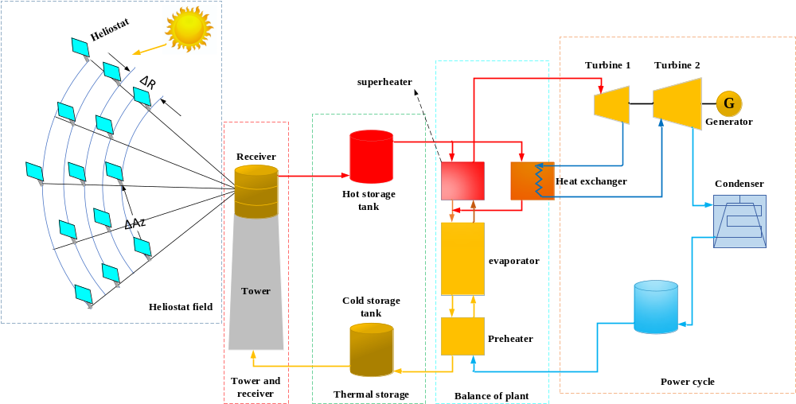
Figure 5 A schematic diagram of solar power tower molten salt system (SPTMS).

Project Description
Case Study: optional (case study should have a good potential for solar thermal-see lecture 10, for example Spain, UAE, United States, India, etc.)
Capacity of the System: 100 MWe
Simulation tool: SAM

Project content
Project should be presented in the following form:
- Introduction (regarding energy source, technology and case study) (10 points)
- Case study (Plot: solar radiation, dry bulb temperature and wind speed for the case study region) (10 points)
- Material and methods (a short explanation about each power plant and simulation tool) (15 points)
- Results and discussion ((Summary of energy and economic analysis for each power plant (annual energy, capacity factor, LCOE (nominal), net capital cost)); Efficiency of each power plant (you can discuss the efficiency of each power plant in different sections such as receiver thermal efficiency, field optical efficiency, etc.); System power generated (profile or time series or heat map)) (30 points)
- Conclusions (compare the power plants and discuss the results) (15 points)
Presentation (20 points)
References
[1] A. Khosravi, V. Olkkonen, A. Farsaei, and S. Syri, “Replacing hard coal with wind and nuclear power in Finland- impacts on electricity and district heating markets,” Energy, vol. 203, p. 117884, Jul. 2020.
[2] X. Wei, Z. Lu, Z. Wang, W. Yu, H. Zhang, and Z. Yao, “A new method for the design of the heliostat field layout for solar tower power plant,” Renew. Energy, vol. 35, no. 9, pp. 1970–1975, Sep. 2010.
[3] S. Benammar, A. Khellaf, and K. Mohammedi, “Contribution to the modeling and simulation of solar power tower plants using energy analysis,” Energy Convers. Manag., vol. 78, pp. 923–930, Feb. 2014.
[4] G. Barigozzi, G. Bonetti, G. Franchini, A. Perdichizzi, and S. Ravelli, “Thermal performance prediction of a solar hybrid gas turbine,” Sol. Energy, vol. 86, no. 7, pp. 2116–2127, Jul. 2012.
[5] L. Aichmayer, J. Spelling, B. Laumert, and T. Fransson, “Micro Gas-Turbine Design for Small-Scale Hybrid Solar Power Plants,” J. Eng. Gas Turbines Power, vol. 135, no. 11, p. 113001, Sep. 2013.
[6] J. Spelling, B. Laumert, and T. Fransson, “A Comparative Thermoeconomic Study of Hybrid Solar Gas-Turbine Power Plants,” J. Eng. Gas Turbines Power, vol. 136, no. 1, p. 011801, Oct. 2013.

